Nyaraya Cluster Examination
Kenya Certificate of Secondary Education

2023 Form Four Evaluation Programme

448/1 ELECTRICITY Paper 1
JULY/AUGUST 2023

Name……………………………………………………..…Index no………………… Candidate’s signature……………
ELECTRICITY
PAPER 1
(THEORY)
2 ½ hour
Kenya certificate of secondary education
ELECTRICITY
PAPER 1
(THEORY)
Instructions to candidates
- This paper consists of two sections: A and B
- Answer all the questions in section A and any four questions from section B in the spaces provided
- All dimensions are in millimeters unless otherwise stated

SECTION A (48 marks)
1 a) State four categories of institutions that train electrical technicians in Kenya (2mks)
………………………………………………………………………………………………………………………………………………………………………………………………………………………………………………………………………………………………………………………………………………………………………………………………………………………………………………………………………………………………………………………………………
b) List four key components of a business plan (2mks)
………………………………………………………………………………………………………………………………………………………………………………………………………………………………………………………………………………………………………………………………………………………………………………………………………………………………………………………………………………………………………………………………………
2a) State how each of the following electrical wates materials should be disposed. (1mks)
i) Lead
……………………………………………………………………………………………………………………………………………………………………………………
ii) Florescent tube
……………………………………………………………………………………………………………………………………………………………………………………
b). State how each of the following type of fire extinguisher is suitably applied (3mks)
- Foam
……………………………………………………………………………………………………………………………………………………………………………………
- Water
……………………………………………………………………………………………………………………………………………………………………………………
- Dry powder
……………………………………………………………………………………………………………………………………………………………………………………

3 A one –watt resistor has the colour code blue, grey, and brown. Determine
- The value of the resistor (1mks)
………………………………………………………………………………………………………………………………………………………………………………………………………………………………………………………………………………………………………………………………………………………………………………………………
- The maximum value of the current that can flow through it without exceeding its power rating (4mks)
………………………………………………………………………………………………………………………………………………………………………………………………………………………………………………………………………………………………………………………………………………………………………………………………
4a) State lenz’s law of electromagnetic induction (1mk)
…………………………………………………………………………………………………………………………………………………………………………........................................................
b). State two characteristics of magnetic lines of force (2mks)
………………………………………………………………………………………………………………………………………………………………………………………………………………………………………………………………………………………………………………………………………………………………………………………………………………………………5 a) Explain the meaning of sensitivity as used in meter movement (1mk)
………………………………………………………………………………………………………………………………………………………………………………………………………………………………………………………………………………………………………………………
b). With the aid of a diagram, show how the linearity of a meter is determined (4mks)
………………………………………………………………………………………………………………………………………………………………………………………………………………………………………………………………………………………………………………………………………………………………………………………………………………………………………………………………………………………………………………………………………………………………………………………………………………………………………………………………………………………………………………………………………………………………………………………………………………………………………………………………………………………………………………………………………………………………………………………………………………………………………………………………………………
6 a) With the aid of a diagram, describe armature reaction in d.c. generator (4mks)
………………………………………………………………………………………………………………………………………………………………………………………………………………………………………………………………………………………………………………………………………………………………………………………………………………………………………………………………………………………………………………………………………………………………………………………………………………………………………………………………………………………………………………………………………………………………………………………………………………………………………………………………………………………………………………………………………………………………………………………………………………………………………………………………………………
b). Outline two methods of reducing armature reaction. (2mks)
………………………………………………………………………………………………………………………………………………………………………………………………………………………………………………………………………………………………………………………………………………………………………………………………………………………………
7a) Distinguish between intrinsic and extrinsic semi –conductors and give one example of each. (3mks)
………………………………………………………………………………………………………………………………………………………………………………………………………………………………………………………………………………………………………………………………………………………………………………………………………………………………………………………………………………………………………………………………………
b). List four uses of an ohmmeter in trouble shooting electric circuits (2mks)
………………………………………………………………………………………………………………………………………………………………………………………………………………………………………………………………………………………………………………………………………………………………………………………………………………………………

8 a) Name four conductor materials used in electric circuits (2mks)
………………………………………………………………………………………………………………………………………………………………………………………………………………………………………………………………………………………………………………………………………………………………………………………………………………………………
b). State two advantages of MIMS over PVC cables (2mks) ………………………………………………………………………………………………………………………………………………………………………………………………………………………………………………………………………………………………………………………………………………………………………………………….......................................................
9. Figure 1 shows a series –parallel circuit connected across a 240V supply
Calculate the:
- Total circuit current (2mks)
………………………………………………………………………………………………………………………………………………………………………………………………………………………………………………………………………………………………………………………………………………………………………………………………………………………………………………………………………………………………
- Voltage drop across (4mks)
- R₃
………………………………………………………………………………………………………………………………………………………………………………………………………………………………………………………………………………………………………………………………………………………………………………………………………………………………………………………
- R₄
……………………………………………………………………………………………………………………………………………………………………………………………………………………………………………………………………………………………………………………………………………………………………………………………………………………………………………………………………………………………………………………………………………………………………………………………………………………………………………………………………………..
10 a) Name four marking out tools used in metal fabrication (2mks)
………………………………………………………………………………………………………………………………………………………………………………………………………………………………………………………………………………………………………………………………………………………………………………………………………………………………
b). Figure 2 shows the orthographic views of a bracket drawn in first angle projection

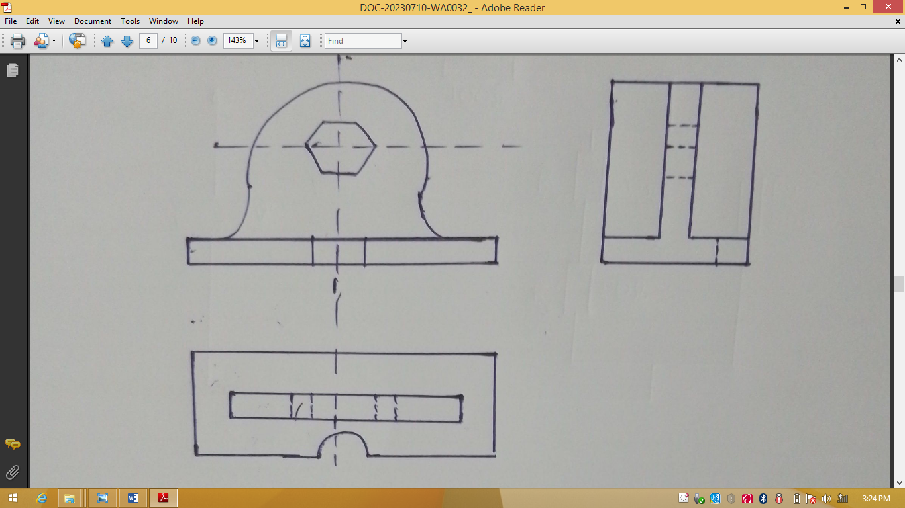

Taking N as the lowest point,make a free hand isometric sketch of the bracket (4mks)

SECTION B (52 marks)
11.a) Convert (4mks)
i) 41₁₀ to binary
………………………………………………………………………………………………………………………………………………………………………………………………………………………………………………………………………………………………………………………………………………………………………………………………………………………………………………………………………………………………………………………………………………………………………………………………………………………………………………………………………………………………………………………………………………………
ii) 1101101₂ to decimal
………………………………………………………………………………………………………………………………………………………………………………………………………………………………………………………………………………………………………………………………………………………………………………………………………………………………………………………………………………………………………………………………………………………………………………………………………………………………………………
b). Sketch the symbol for each of the following logic gates (3mks)
i) AND

- OR

iii). NAND

12. a) State three advantages of toroidal type transformer over shell type transformer (3mks)
………………………………………………………………………………………………………………………………………………………………………………………………………………………………………………………………………………………………………………………………………………………………………………………………………………………………………………………………………………………………………………………………………
b). i) Outline three assumptions made in order to consider a transformer as an ideal machine.
(3mks)
………………………………………………………………………………………………………………………………………………………………………………………………………………………………………………………………………………………………………………………………………………………………………………………………………………………………………………………………………………………………………………………………………
ii). A 500/500V,10KVA ideal single –phase transformer has 40 turns on the secondary. Calculate
i) Primary turns (2mks)
………………………………………………………………………………………………………………………………………………………………………………………………………………………………………………………………………………………………………………………………………………………………………………………………………………………………………………………………………………………………………………………………………
ii) Primary full load current (2mks)
………………………………………………………………………………………………………………………………………………………………………………………………………………………………………………………………………………………………………………………………………………………………………………………………………………………………………………………………………………………………………………………………………
iii) Secondary full load current (2mks)
………………………………………………………………………………………………………………………………………………………………………………………………………………………………………………………………………………………………………………………………………………………………………………………………………………………………………………………………………………………………………………………………………

13. a) State the phase relationship between current and voltage in circuits that are purely. (2mks)
i) Resistive
………………………………………………………………………………………………………………………………………………………………………………………………………………………………………………………………………………………………………………………
ii). Inductive
………………………………………………………………………………………………………………………………………………………………………………………………………………………………………………………………………………………………………………………
b). Figure 3 shows an RLC circuit
Calculate the (11mks)
- Inductive reactance
………………………………………………………………………………………………………………………………………………………………………………………………………………………………………………………………………………………………………………………………………………………………………………………………………………………………………………………………………………………………………………………………………………………………
- Capacitive reactance
……………………………………………………………………………………………………………………………………………………………………………………………………………………………………………………………………………………………………………………….............................................................................

- Circuit impedance
……………………………………………………………………………………………………………………………………………………………………………………………………………………………………………………………………………………………………………………………………………………………………………………………………………………………………………………………………
- Circuit current
……………………………………………………………………………………………………………………………………………………………………………………………………………………………………………………………………………………………………………………………………………………………………………………………………………………………………………………………………
- Power dissipated in the circuit
………………………………………………………………………………………………………………………………………………………………………………………………………………………………………………………………………………………………………………………………………………………………………………………………………………………………………………………………………………………………………………………………………………………………..

14 a) State (4mks)
- Two IEE requirements regarding bell transformers
……………………………………………………………………………………………………………………………………………………………………………………………………………………………………………………………………………………………………………………………………………………………………………………………………………………………………………………………………
- Two advantages of MCB over cartridge fuses
……………………………………………………………………………………………………………………………………………………………………………………………………………………………………………………………………………………………………………………………………………………………………………………………………………………………………………………………………

b). Outline the procedure of carrying out an insulation resistance test on a new domestic insulation (9mks)
………………………………………………………………………………………………………………………………………………………………………………………………………………………………………………………………………………………………………………………………………………………………………………………………………………………………………………………………………………………………………………………………………………………………………………………………………………………………………………………………………………………………………………………………………………………………………………………………………………………………………………………………………………………………………………………………………………………………………………………………………………………………………………………………………………………………………………………………………………………………………………………
15. a) With the aid of a diagram, explain how the right hand grip rule is used to determine the direction of the magnetic field around a current carrying conductor (3mks)
………………………………………………………………………………………………………………………………………………………………………………………………………………………………………………………………………………………………………………………………………………………………………………………………………………………………………………………………………………………………………………………………………………………………………………………………………………………………………………………………………………………………………………………………………………………
b). With the aid of a labelled diagram, explain the principle of operation of a trembler bell.
(10mks)

