Nyaraya Cluster Examination
Kenya Certificate of Secondary Education
Form Four Mock Evaluation Programme

121/1 MATHEMATICS ALT. A Paper 1
JULY 2023 – TIME: 2½ HOURS

Name: ………………………………………………………………... Adm No: ……….……
Index Number: …….……………... Candidate’s Signature: …….………......
School………………………………………………….Stream …………………………...

Instructions to Candidates
- Write your name, Adm. Number and stream in the spaces provided at the top of this page.
- This paper consists of TWO sections: Section I and Section II.
- Answer ALL the questions in Section I and any five questions from Section II.
- Show all the steps in your calculation, giving your answer at each stage in the
spaces provided below each question.
- Marks may be given for correct working even if the answer is wrong.
- Non-programmable silent electronic calculators and KNEC Mathematical tables
may be used, except where stated otherwise.
- This paper consists of 15 printed pages.
- Candidates should check the question paper to ascertain that all the pages are
printed as indicated and that no questions are missing.
- Candidates should answer the questions in English.

For Examiner’s Use Only
Section I
1 | 2 | 3 | 4 | 5 | 6 | 7 | 8 | 9 | 10 | 11 | 12 | 13 | 14 | 15 | 16 | Total

Section II

Grand
Total

17 | 18 | 19 | 20 | 21 | 22 | 23 | 24 | Total

SECTION I (50 marks)
Answer all questions in this section in the spaces provided.
- A normal year has 365 days while a leap year has 366 days. Find the number of days from the beginning of 1900 to end of 2000. (2 marks)

- Find the exact value $2.\dot{2}+3.2\dot{4}$ in its simplest form. (3 marks)

- A mirror line maps point (4,3) onto (-2,7). Find the equation of the mirror line in double intercept form. (4 marks)

- The average lap time of 3 cars in a racing competition is 36 seconds, 40 seconds and 48 seconds respectively. If they all start the race at the same time, find the number of times the slowest car will have been overlapped by the fastest at the time they all cross the starting point together again. (4 marks)

- The table below shows patients who attend a clinic in one week and were grouped by age as shown in the table below.
Age x years | 0≤ x < 5 | 5≤ x < 15 | 15≤ x < 25 | 25≤ x < 45 | 45≤ x < 75
Number of patients | 14 | 41 | 59 | 70 | 15

On the grid provided draw a histogram to represent the distribution. (3 marks)

- Three farmers, Formula-One, Method-Two and Way-Three are to share a grazing field. Formula-One has 5 cows, Method-Two has 7 cows and Way-Three has 4 cows. The three grazed for 3 days, 2 days and 4 days respectively. The owner of the field charged them ksh. 9000 which they were to share proportionately. How much money did Formula-One contribute? (3 marks)

- a) Simplify the expression $\frac{3x+5}{2x}-\frac{2x+8}{3x}$. (1 mark)

b) Hence solve $\frac{3x+5}{2x}-\frac{2x+8}{3x}=\frac{4}{5}$ (2 marks)

- A solid in the shape of a regular nonagon with distance from the centre to any vertex as 10cm and length 3.5m has a density of $3.2g{cm}^{-1}.$ Calculate to 3 significant figures the mass of the solid in kilograms. (4 marks)

- Find the exact value of $\frac{3^{n+1}-3×3^{n-1}}{4×3^{n+2}}$ (3 marks)

- Use tables of natural tangents and square roots to find
- $tan{72.63}^{0}$ (2 marks)

- $\sqrt{0.5479}$ (1 mark)

- Hence evaluate $tan{72.63}^{0}+\sqrt{0.5479}$ (1 mark)

- Given the column vectors , and and that. Find the magnitude of p to 3 significant figures. (3 marks)

- Using the grid below, solve the simultaneous equations below (3 marks)
$$x+3y=9 and 3x+2y=13$$

- Under an enlargement with scale factor +2, point $P(2,9)$ is mapped onto $P'(-5,3)$. Determine the co-ordinates of the centre of enlargement. (3 marks)

- A businessman sells two types of mobile phones Samsung and Nokia. The price of one Samsung and one Nokia is ksh. 2000 and ksh. 1600 respectively. He wishes to have at least 20 mobile phones. The number of Samsung phones, should be less or equal to the number of Nokia phones. He has ksh. 96 000 to spend. If he buys x Samsung phone and y Nokia phones, write down the inequalities for the above situation. (3 marks)

- Complete the figure below to show a rotational symmetry of order 3 about point O. (3 marks)

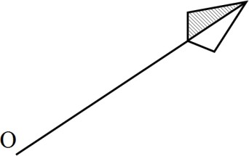

- Solve for $α$ in $2sin\left(2α+20\right)-2cos\left(-α-30\right)=0$ (2 marks)

SECTION II (50 MARKS)
(Answer ANY FIVE questions in the spaces provided)
- The distance between Kipsigis Girls and Mbita School is 240km. During the Champions Jet 1 result release at Kipsigis Girls, Mbita School ferried their students using two buses, Scania and Isuzu. The Scania bus travelled 20km/h faster than the Isuzu bus whose speed was $xkm/h$.
- Write an expression in terms of x for the time taken to cover the distance by;
- Isuzu bus (1 mark)

- Scania bus (1 mark)

- The Isuzu bus left Mbita at 7.00 am. and 36 minutes later, the Scania bus left Mbita for Kipsigis. The two vehicles reached Kipsigis Girls at the same time. Form an equation in $x$ hence find the speed of Scania bus. (5 marks)

- During the return journey, the two buses left Kipsigis at the same time and maintained their original speeds. The Scania bus developed a puncture after covering 100km which took 20 minutes to mend. If the two buses arrived at Mbita at the same time, find the average speed of Scania bus from the point where the tire was mended. (3 marks)

- Sol is a sales lady with a company that pays her a basic salary of sh. 30,000 per month. She is also given commission on goods sold as follows,
$0\%$ for the first sh. 100,000
$3\%$ on the sales above sh. 100,000 up to sh. 300,000
$7.5\%$ of sales above sh. 300,000
- During the month of May, she sold 400 calculators at sh. 1250 per calculator. Calculate:
- How much she collected from the sale of calculators. (2 marks)

- Her total earnings for the month of May. (3 marks)

- During the month of June, each calculator was sold at a discount of 16.8%. If Sol received a total of sh. 52,500 as her earnings, find the total number of calculators sold during the month of June. (5 marks)

- Two quadratic curves intersect at points $\left(-2,0\right)$ and $\left(4,0\right)$.
- Determine the equations of the curves in the form $y=ax^{2}+bx+c$. (4 marks)

- Using trapezium rule with 6 strips, estimate the area bounded by the curves. (4 marks)

- Estimate the area in (b) above using mid-ordinate rule with 3 trapezia. (2 marks)

- A, B, C, D and E are such that B is 88 km on a bearing of ${062}^{0}$ from A. C is 120 km on a bearing of ${142}^{0}$ from B. D is $S{38}^{0}W$ of C at a distance of 90km. E lies directly South of A and directly west of D. Using a scale of $1:2,000,000$;
- Determine the relative positions of A, B, C, D and E. (4 marks)

- Find the bearing and distance of (4 marks)
- E from C

- D from A

- Find the area covered by A, B,C D and E in square kilometers. (2 marks)

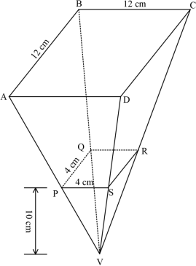
- The diagram below represents square based pyramid standing vertically. AB = 12 cm, PQ = 4 cm and the height of the pyramid PQSV is 10 cm.

- If PQRSV is a solid, find the volume of material used to make it.

- Find the;
  - Height of the frustum ABCDPQRS.

  - Volume of the frustum.

- The liquid from a hemisphere is poured into ABCDPQRS. Find the radius correct to 4 significant figures of the hemisphere if the liquid from hemisphere filled the solid completely.$(π=3.142)$

- The equation of a curve is given as $y=x^{3}-6x^{2}+9x+20.$
- Find ;
- the $y-intercept$ of the curve. (2 marks)

- the stationary points of the curve. (3 marks)

- For each stationary point in (a) (ii) above, determine its nature. (2 marks)

- Sketch the curve. (2 marks)

23. The figure below shows a quadrilateral ABCD. ABD is a right angled triangle. Given that $AB=12cm$, $BC=10cm$, $AD = 8cm$, and angle $DBC= 115°$.
D C

8cm 10cm
$115°$
A 12cm B
Calculate to one decimal place:
- The length BD (2marks)

- The length CD (3marks)

- The angle BCD (2marks)

- The area of the quadrilateral ABCD (3marks)

- In the figure below, O is the centre of the circle TOR is the diameter and PRV is tangent to the circle at R.
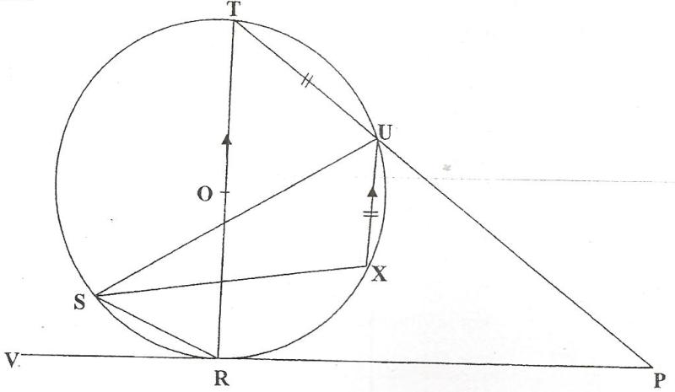

Given that <SUR = 25⁰, <URP = 60⁰, TU = UX is parallel to the diameter; giving reasons calculate;

- <TOU (2 marks)

- <XUP (2 marks)

- <STR (2 marks)

- Reflex <SXU (2 marks)

- <RPU (2 marks)

