Nyaraya Cluster Examination
Kenya Certificate of Secondary Education
Form Four Mock Evaluation Programme

Name…………………………………………………. Index Number……………………..
School…………………………………………………Adm No…………. Stream……….

Candidate’s signature......................................... Date…………………………………….

PHYSICS
Paper 1 Theory
JULY 2023

2 hours

PHYSICS PAPER 1 (THEORY)

Instructions to the candidate:
- Write your name, index number and school in the spaces provided above.
- Sign and write the date of examination in the spaces provided above.
- This paper consists of two Sections A and B.
- Answer all the questions in sections A and B in the spaces provided.
- All working must be clearly shown in the spaces provided.
- Mathematical tables and electronic calculators may be used.
- This paper consists of 12 printed pages

- Candidates should check the question paper to ascertain that all the pages are printed as indicated and that no questions are missing

For Examiner’s Use Only:

Section | Question | Maximum | Candidate’s
 |  | Score | Score
A | 1–14 | 25
 | 15 | 08
 | 16 | 13
B
 | 17 | 14
 | 18 | 11
 | 19 | 09
Total Score |  | 80

SECTION A: (25 marks):

Answer all the questions in this section in the spaces provided
- Figure 1 shows a section of a burette filled with a colourless liquid.

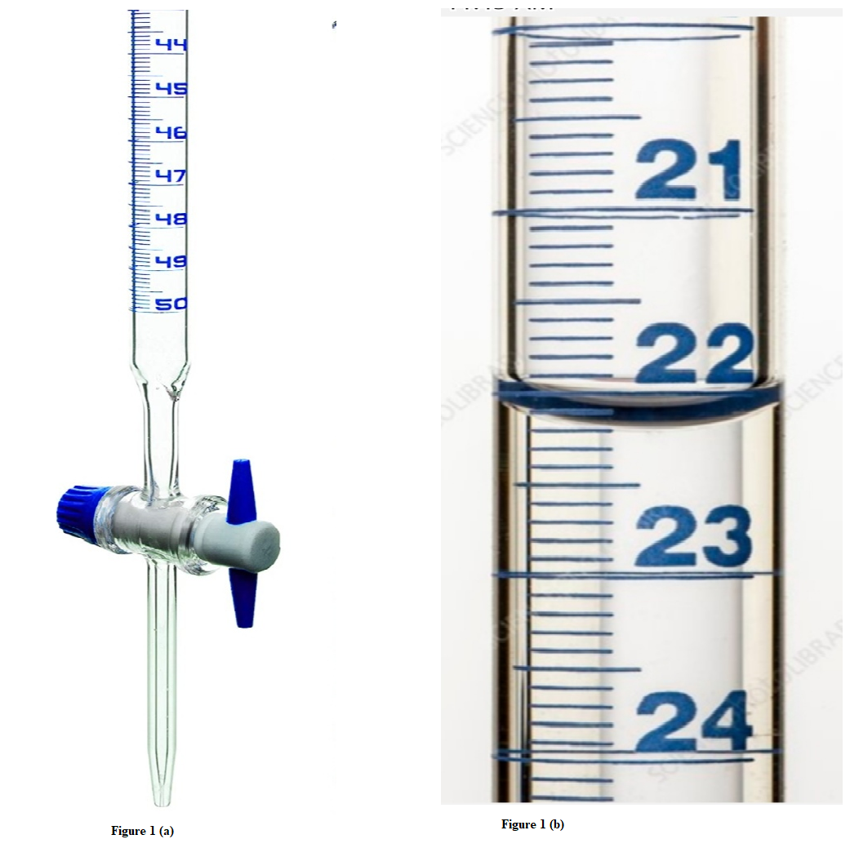
Figure 1
Figure 1(b) shows a magnified scale indicating new level of liquid in the burette after some volume x of the liquid has been removed.
- State the new level of the liquid shown in figure 1(b). (1mk)

(ii) Determine the value of x. (1mk)

- A form one student set up the apparatus as shown in figure 2.
Floating wax
Flame
Water
Wax fitted with lead shot
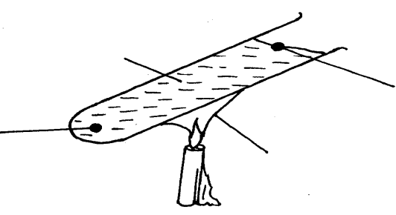
Figure 2

The boiling tube was heated in the middle as shown
(i) Which wax melted? (1mk)

(ii) Explain your answer in (i) above. (1mk)

- State the SI unit of gravitational field intensity. (1mk)

- Define force in terms of momentum (1mk)

- A body is uniformly accelerated from rest to a final velocity of 100ms⁻² in 10s. Determine the distance covered. (2mks)

- Figure 3 shows a siphon used to empty a tank.

Figure 3

In order to start the siphon, give a reason why the tube must be filled with a liquid and end X must be below the level of the liquid in the tank. (2mks)

- Explain how a piece of chalk can be used to demonstrate that matter is made up of tiny particles. (1mk)

- The figure 4 shows a uniform meter rule of weight 1N with two weights of weight 0.18N and 0.12N suspend from its ends.
Figure 4
W = 1N
0.18 N
0.12 N
50
0
100 cm

Determine how far from the 0.18 N weight a pivot should be placed in order to balance meter rule. (3mks)

- State any two changes that can be made to a fluid flowing in a streamline flow to make it turbulent flow. (2mks)

- The solid marble shown below is in a stable equilibrium. On the space provided, sketch the same marble in a neutral state of equilibrium (1mk)

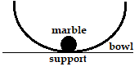
Figure 5

- Show that the impulsive force on an object can be expressed as F = ma. (3mks)

- Figure 6 shows a beaker full of water at 90oC. The beaker is fitted with two identical thermometers A and B and a cold wet clothe wrapped around the middle of the beakers as shown in the diagram.
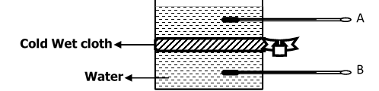

Figure 6
- State which thermometer will show a lower reading after some minutes. (1mk)

- Explain your answer in (i) above. (1mk)

- Two springs X and Y are defined as follows: X has a spring constant of 25N/m and Y has a spring constant of Y. Sketch on the axes below graphs representing the behaviour of X and Y. (1mk)

Force

Extension

- In an oil drop experiment to determine the size of an oil molecule certain assumptions are usually made. State any two assumptions. (2mks)

SECTION B (55 MARKS)
Answer all questions in the spaces provided below each question.

- (a) The graph in figure 7 shows changes of pressure and volume of a fixed mass of a gas.

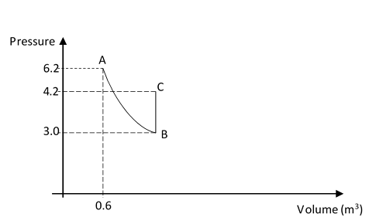
Figure 7
(i) Calculate the volume of the gas at B. (4mks)

(ii) I. Name the gas law represented by the graph between B and C. (1mk)

II. Give one way of increasing pressure at constant volume between B and C. (1mk)

(b) Show that density of a fixed mass of a gas is directly proportional to the pressure at constant temperature. (3mks)

- (a) Define angular velocity as used in circular motion. (1mk)

- The graph in figure 8 was obtained in an experiment to investigate the variation of the centripetal force, F, with the radius, r of the circle on a turn table.
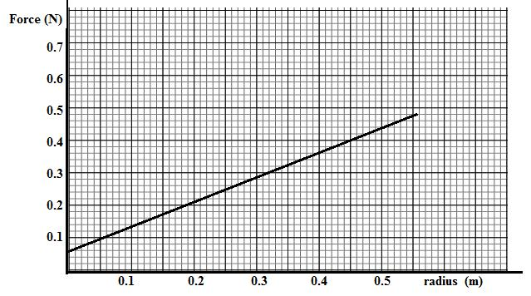
Figure 8

-

Given that the relationship between force, F, and radius, r, is of the form F = mω²r + C. Where c is a constant. Determine the angular velocity, w and the constant C of the body given that m = 100g. (4mks)

(c) Explain why the earth is said to be accelerating when revolving around the sun at

constant speed. (1mk)

- Figure 9 below shows a toy attached to a string and made to move along a vertical circle in an anti-clockwise direction.
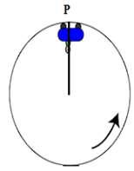
Figure 9

(i) Sketch on the diagram above, the path followed by the trolley if the string cuts when it is at position P. (1mk)

- the variation of tension in the string with time as the trolley moved along the vertical circle was plotted in the graph shown in figure 10.

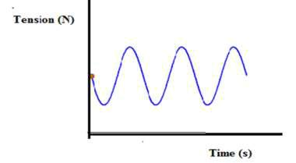
Figure 10

- Mark on the graph the points T corresponding to position P in the circle shown in figure 12 above (1mk)

- Give a reason why the graph is not touching the time axis (1mk)

- A body moving with uniform angular velocity found to have covered an angular distance 170 radians in t seconds. Thirteen seconds later it is found to have covered a total angular distance of 300 radians. Determine t. (4mks)

- (a) The figure 11 shows a domestic refrigerator.
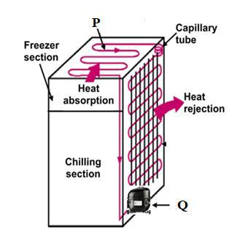
Figure 11

- Name the parts P and Q (2mks)

- Explain how cooling is achieved in the refrigerator. (3mks)

- The shelves in a refrigerator are made of metal gauze instead of metal plates. Explain. (2mks)

(b) A copper can together with a stirrer of total heat capacity 60J/k contains 200g of water at 10ºC. Dry steam at 100⁰C is passed in while the water is stirred until the whole reach a temperature of 30⁰C. Determine the mass of steam condensed. (Specific heat capacity of water=4200J/kgK and specific latent heat of vaporization of steam(water) =2260000J/kg).
(5mks)

c) Increase in pressure increases the boiling point of a liquid. Explain how a pressure cooker helps in achieving this situation. (2mks)

18. (a) State the law of flotation. (1mk)

(b) You are provided with the following;
-A block of wood, a spring balance, thin thread, overflow can, measuring cylinder and some liquid.

With the aid of labelled diagram(s) describe an experiment to verify the law of flotation.
(5mks)

c) Determine the minimum volume of copper that must be attached to a cork of mass 25g so that the two just submerge in water. (Relative density of copper and cork are 9.0 and 0.25 respectively). (3mks)

- State two reasons why density bottle may be preferred to measure relative density.
(2mks)

19 (a) Figure 12 shows a lever being used to raise a load of 100N.

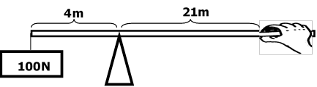
Figure 12

(i) Determine

- the effort applied. (2mks)

- The velocity ratio and mechanical advantage. (2mks)

III) Efficiency of the machine. (2mks)

(b) Give two ways in which the mechanical advantage could be increased. (2mks)

THIS IS THE LAST PRINTED PAGE

