Nyaraya Cluster Examination
Kenya Certificate of Secondary Education
Form Four Mock Evaluation Programme

MARKING SCHEME

232/1 PHYSICS PAPER 1 (THEORY)

Instructions to the candidate:
- Write your name, index number and school in the spaces provided above.
- Sign and write the date of examination in the spaces provided above.
- This paper consists of two Sections A and B.
- Answer all the questions in sections A and B in the spaces provided.
- All working must be clearly shown in the spaces provided.
- Mathematical tables and electronic calculators may be used.
- This paper consists of 11 printed pages

- Candidates should check the question paper to ascertain that all the pages are printed as indicated and that no questions are missing

For Examiner’s Use Only:

Section | Question | Maximum | Candidate’s
 |  | Score | Score
A | 1–14 | 25
 | 15 | 08
 | 16 | 13
B
 | 17 | 14
 | 18 | 11
 | 19 | 09
Total Score |  | 80

SECTION A: (25 marks):

Answer all the questions in this section in the spaces provided
- Figure 1 shows a section of a burette filled with a colourless liquid.

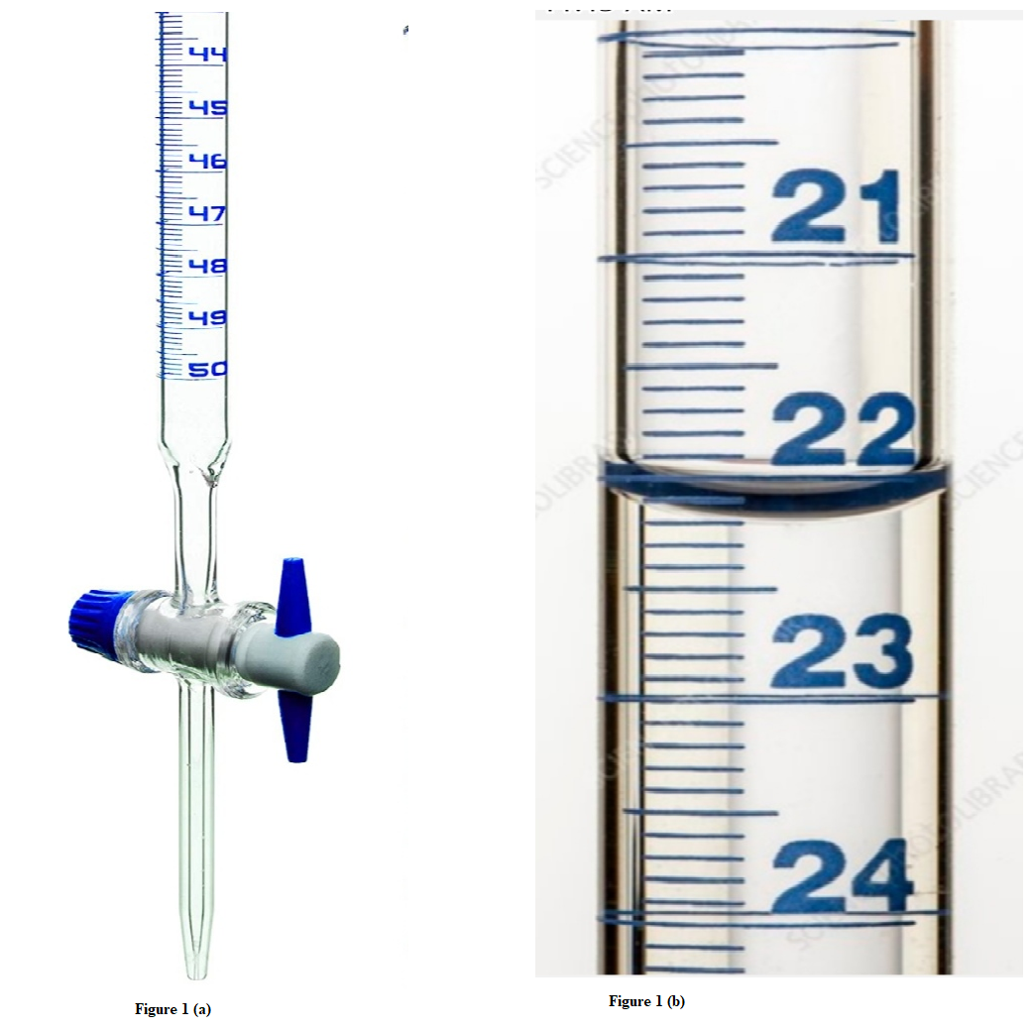
Figure 1
Figure 1(b) shows a magnified scale indicating new level of liquid in the burette after some volume x of the liquid has been removed.
- State the new level of the liquid shown in figure 1(b). (1mk)
22.2 cm³ √

(ii) Determine the value of x. (1mk)

22.2 cm³ √

- A form one student set up the apparatus as shown in figure 2.
Floating wax
Flame
Water
Wax fitted with lead shot
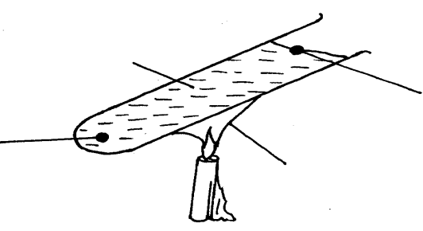
Figure 2

The boiling tube was heated in the middle as shown
(i) Which wax melted? (1mk)
Floating wax √
(ii) Explain your answer in (i) above. (1mk)
Heated water rises by convection to melt the wax; √; poor conductor water does not conduct heat to melt fitted wax in lead.
- State the SI unit of gravitational field intensity. (1mk)
newton per kilogram.
- Define force in terms of momentum (1mk)

Rate of change of momentum. √

- A body is uniformly accelerated from rest to a final velocity of 100ms⁻² in 10s. Determine the distance covered. (2mks)
$100=0+ax10;a=10ms^{-2}; v^{2}=u^{2}+2as ;{100}^{2}=0^{2}+2x10xs √;s=500m√$
- Figure 3 shows a siphon used to empty a tank.

Figure 3

In order to start the siphon, give a reason why the tube must be filled with a liquid and end X must be below the level of the liquid in the tank. (2mks)

-To provide cohesion between molecules of the liquid flow to occur/ pull liquid downward by cohesive force. √
-End X must be below the level of the liquid to create pressure difference. √
- Explain how a piece of chalk can be used to demonstrate that matter is made up of tiny particles. (1mk)
The piece of paper can be cut/teared / torn into tiny/smaller pieces. √

- The figure 4 shows a uniform meter rule of weight 1N with two weights of weight 0.18N and 0.12N suspend from its ends.
Figure 4
W = 1N
0.18 N
0.12 N
50
0
100 cm

Determine how far from the 0.18 N weight a pivot should be placed in order to balance meter rule. (3mks)
$F1d1=F2d2 √;0.18x=1\left(50-x\right)+0.12\left(100-x\right) √;x=47.69cm√$

- State any two changes that can be made to a fluid flowing in a streamline flow to make it turbulent flow. (2mks)
-Increase in fluid velocity beyond critical speed. √
- Sudden change in the shape of tube of flow. √
- The solid marble shown below is in a stable equilibrium. On the space provided, sketch the same marble in a neutral state of equilibrium (1mk)

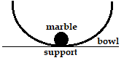
Figure 5

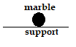√

- Show that the impulsive force on an object can be expressed as F = ma. (3mks)
$$F=\frac{mv-mu}{t} √;F=m\left(\frac{v-u}{t}\right)√;but \frac{v-u}{t}=a ;F=ma√$$

- Figure 6 shows a beaker full of water at 90oC. The beaker is fitted with two identical thermometers A and B and a cold wet clothe wrapped around the middle of the beakers as shown in the diagram.
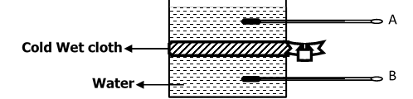

Figure 6
- State which thermometer will show a lower reading after some minutes. (1mk)
Thermometer B √

- Explain your answer in (i) above. (1mk)
Cold water absorbs latent heat of vaporization cooling the water at that point; √ water at the point becomes denser moving downwards and less dense hot water rises.

- Two springs X and Y are defined as follows: X has a spring constant of 25N/m and Y has a spring constant of 100N/m. Sketch on the axes below graphs representing the behaviour of X and Y. (1mk)
Y

X
Force

√ both lines.

Extension

- In an oil drop experiment to determine the size of an oil molecule certain assumptions are usually made. State any two assumptions. (2mks)

-Oil patch is monolayer/ one molecule in thickness. √ any two
- Oil drop is perfectly spherical. √
- Oil patch is perfectly circular
SECTION B (55 MARKS)
Answer all questions in the spaces provided below each question.

- (a) The graph in figure 7 shows changes of pressure and volume of a fixed mass of a gas.

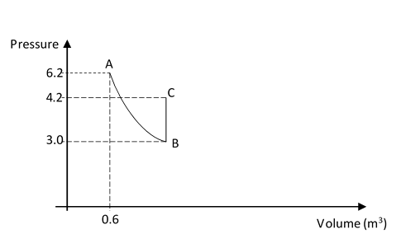
Figure 7
(i) Calculate the volume of the gas at B. (4mks)

P₁V₁=P₂V₂√
6.2X0.6=3.0XV₂√
V₂=1.24M³ √
(ii) I. Name the gas law represented by the graph between B and C. (1mk)
Pressure law√

II. Give one way of increasing pressure at constant volume between B and C. (1mk)
Warming the gas/ heating/increasing temperature√

(b) Show that density of a fixed mass of a gas is directly proportional to the pressure at constant temperature. (3mks)

PV= constant√
$but V=\frac{m}{ρ} , P\frac{m}{ρ}=constant$√
$ρ=\frac{pxm}{constant}$, √ hence density is directly proportional to pressure for a fixed mass of a gas.

- (a) Define angular velocity as used in circular motion. (1mk)

Rate of change of angular displacement√

- The graph in figure 8 was obtained in an experiment to investigate the variation of the centripetal force, F, with the radius, r of the circle on a turn table.
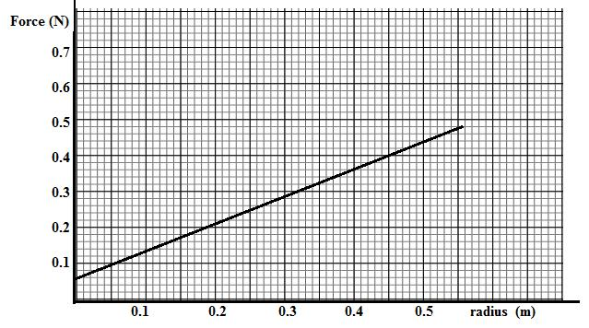
Figure 8

-

Given that the relationship between force, F, and radius, r, is of the form F = mω²r + C. where C is a constant. Determine the angular velocity, w and the constant C of the body given that m = 100g. (4mks)

$$Slope=\frac{\left(0.4-0.06\right)}{\left(0.45-0\right)} √=\frac{0.34}{0.45}=0.7556√; slope=mω^{2};0.7556=0.1xω^{2} √ ;ω=2.7488 rads^{-1} √$$

(c) Explain why the earth is said to be accelerating when revolving around the sun at

constant speed. (1mk)

-Change in the instantaneous velocity√ of the earth.

- Figure 9 below shows a toy attached to a string and made to move along a vertical circle in an anti-clockwise direction.
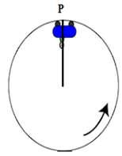
Figure 9

(i) Sketch on the diagram above, the path followed by the trolley if the string cuts when it is at position P. (1mk)

- the variation of tension in the string with time as the trolley moved along the vertical circle was plotted in the graph shown in figure 10.

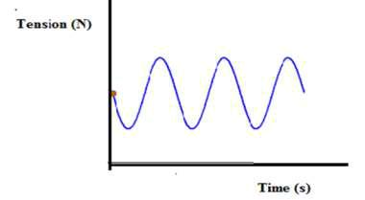
Figure 10

- Mark on the graph the points T corresponding to position P in the circle shown in figure 12 above (1mk)

- Give a reason why the graph is not touching the time axis (1mk)
Tension is dependent on centripetal force and weight of the body; hence cannot be zero. √

- A body moving with uniform angular velocity found to have covered an angular distance 170 radians in t seconds. Thirteen seconds later it is found to have covered a total angular distance of 300 radians. Determine t. (4mks)

$Angular velocity ω=\frac{θ^{c}}{∆t}=\frac{300}{13} √=23.07 rads^{-1} √ ;23.07=\frac{170}{t} √ ;t=7.369 s$√

- (a) The figure 11 shows a domestic refrigerator.
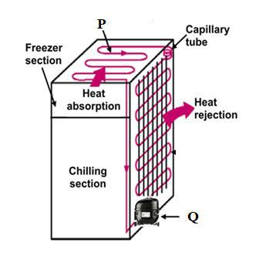
Figure 11

- Name the parts P and Q (2mks)
P- Evaporator pipes√
Q-Compressor pump√
- Explain how cooling is achieved in the refrigerator. (3mks)
The volatile liquid (freon) evaporates by absorbing the latent from air around cooling the cabinet in the freezing compartment; √ The vapour is removed by the compression pump into the lower coil where it is cooled and condenses (changes back) to liquid; giving out its latent heat. √ Liquid goes back to the upper coil and freezing compartment and the process repeats. √

- The shelves in a refrigerator are made of metal gauze instead of metal plates. Explain. (2mks)
The metal gauze allows convection of air to occur through all compartments√ while metal plates confine convection to each compartment. √

(b) A copper can together with a stirrer of total heat capacity 60J/k contains 200g of water at 10ºC. Dry steam at 100⁰C is passed in while the water is stirred until the whole reach a temperature of 30⁰C. Determine the mass of steam condensed. (Specific heat capacity of water=4200J/kgK and specific latent heat of vaporization of steam(water) =2260000J/kg).
(5mks)
Heat gained by calorimeter+ Heat gained by water =heat lost by steam to water at 100⁰ + Heat lost by water from 100⁰ to 30^{0.} √

C∆θ + Mc∆θ = mlv +mc∆θ

(60x20) + (0.2x4200x20) √ = mx2260000 + mx4200(100-70) √

1200+16800 = 2260000m+294000m√

18000 = 2554000m

M=0.007048 kg. √

c) Increase in pressure increases the boiling point of a liquid. Explain how a pressure cooker helps in achieving this situation. (2mks)
The tight-fitting lid prevents free escape of steam√; causing pressure build up to almost twice the atmospheric pressure; √increasing boiling point to higher temperature.

18. (a) State the law of flotation. (1mk)

A floating object displaces its own weight of the fluid in which it floats. √

(b) You are provided with the following;
-A block of wood, a spring balance, weighing balance, thin thread, overflow can, measuring cylinder and some liquid.

With the aid of labelled diagram(s) describe an experiment to verify the law of flotation.
(5mks)
-Using a spring balance, weigh and record the weight of block of wood in air. √
-Fill the Eureka can completely with liquid until it overflows then place the measuring cylinder under spout. √
-Lower the block of wood slowly into liquid until it floats and collect the displaced liquid in the measuring cylinder. √
-Weigh the liquid in the measuring cylinder using weighing balance and note. √
-Compare the weight of the displaced liquid with the weight of the block in air; which are equal. √

(a) weight in air.

(b) Block floating in liquid

c) Determine the minimum volume of copper that must be attached to a cork of mass 25g so that the two just submerge in water. (Relative density of copper and cork are 9.0 and 0.25 respectively). (3mks)

let volume of copper be V.
Volume of cork + volume of copper = total volume of water displaced.
$\frac{25}{0.25}+V=100+V$√
Mass of copper + mass of cork = Mass of water displaced= (100+ V) g
(9V + 25) g = 100+ V √; V = 9.375 cm³√

- State two reasons why density bottle may be preferred to measure relative density.
(2mks)
-Density bottle is more accurate √
- It uses small volumes of liquids. √

19 (a) Figure 12 shows a lever being used to raise a load of 100N.

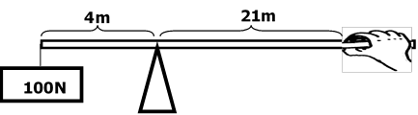
Figure 12

(i) Determine

- the effort applied. (3mks)

F1d1=F2d2√
100x4=Fx21√
Effort applied =19.05N√

- The velocity ratio and mechanical advantage. (2mks)
V.R = 21/4=5.25√
M.A = 100/19.05=5.25√
III) Efficiency of the machine. (2mks)

$$n=\frac{M.A}{V.R}X100\%$$
$$=\frac{5.25}{5.25}X100 √=100\%√$$

(b) Give two ways in which the mechanical advantage could be increased. (2mks)
-increasing the effort distance, √
- Reducing load distance from the pivot. √

THIS IS THE LAST PRINTED PAGE

