Nyaraya Cluster Examination
Kenya Certificate of Secondary Education
Form Four Mock Evaluation Programme

MARKING SCHEME

.

232/2
PHYSICS
PAPER 2

SECTION A (25 MARKS)
Answer all the questions in the spaces provided
- Figure 1 shows a ray of light incident on a plane mirror. The mirror is rotated anticlockwise through an angle of 100.

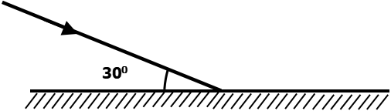
Figure 1
Determine the angle between the incident ray and the new reflected ray. (2marks)
120⁰-2x10 √=100⁰√
2. Figures 2 (a) and 2 (b) show two circuits with identical cells and bulbs.
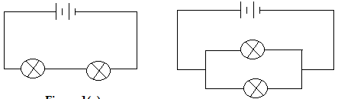
(a)
(b)
Figure 2
State, with a reason, in which circuit the bulbs will be brighter. (2 marks)
Circuit (a)√; more current flows in the circuit than in circuit (b). √
3. Figure 3 shows a wooden rod placed between two bar magnets.
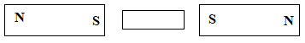
Figure 3
Sketch the resulting magnetic pattern in the arrangement in figure 3. (1 mark)
4.Figure 4 shows a circuit used by a student to investigate the effect of current on a coil.
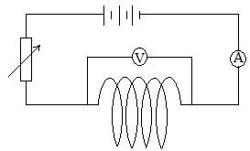
Figure 4
(i) The coil feels warmer after closing the switch. Explain. (1 mark)
The electrical energy is converted to heat energy as a result of resistance. √
OR The flow of electrons through the wire is impeded by collisions with atoms generating heat. √
(ii) The ammeter and voltmeter reading in figure 4 is 1.5A and 4.1V respectively. Calculate the energy developed in 1 minute. (2 marks)
Energy E= Vit √= 4.1x1.5x60√=369J√
5.Give the difference between Infra-red and Ultraviolet radiation in terms of their production.
Infrared | Ultraviolet
Results from small energy changes of an electron in an atom or molecular vibrations. | Results from large energy changes in the electrons of an atom.

6. On the grid provided below, show the display on the CRO screen of an AC signal peak voltage 400V and a frequency 50Hz when the time base is on. (Y-gain at 200V/div, time base at 5ms/div) (2 marks)

Peak voltage= 400/200= 2div both values √ Waveform√
No. of div in the horizontal= 20/4=4 div
7. Figure 5 shows a virtual image I formed by a convex mirror.
Draw a ray diagram to locate the object. (3 marks)
Figure 5
8. The figure 6 shows a cathode ray beam entering a magnetic field, perpendicular to the plane of the paper. Complete the diagram to show the path of the beam in the field. (1 mark)
Figure 6
9. Uranium 235 was bombarded with a neutron and fission took place in the following manner.
$${235 \atop 92}U + {1 \atop 0}n\underset{→}{ }{90 \atop 38}Rn + {a \atop b}X + 10 {1 \atop 0}n$$

Determine the values of a and b (2 marks)
a= 145√ b= 54√
10. Figure 7 shows bulbs connected in a household.
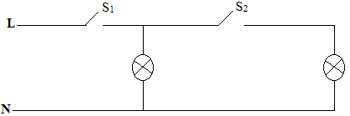
(i) Identify any mistake in the circuit. (1 mark)
Figure 7
-Switch S₁ operates both bulbs.
(ii) Draw the correct connection of the circuit. (1 mark)

11. The resistance of a metal conductor increases with increase in temperature. Explain
(2 marks)
-Increase in temperature increases the vibrations of electrons and atoms; √ causing collisions impeding their flow. √
12. State what is meant by the term doping as used in diode. (1 mark)
-Adding impurities to an intrinsic semiconductor to enhance conductivity. √
13.Two students stand 300m from a wall. One bangs two pieces of wood together and at the same time, the other starts a stop watch. They hear an echo after 1.8 seconds. Determine the speed of sound in air.
(2 marks)
$$v=\frac{2d}{t}√;v=\frac{2x300}{1.8}√;v=333.3m/s√$$
14. Define wavelength as used in longitudinal wave. (1 mark)
The distance between two consecutive rarefactions or compressions. √
SECTION B (55 MARKS)
Answer all the questions in this section in the spaces provided.
15 a) Figure 8 shows the parts and circuit of a modern X-ray tube.
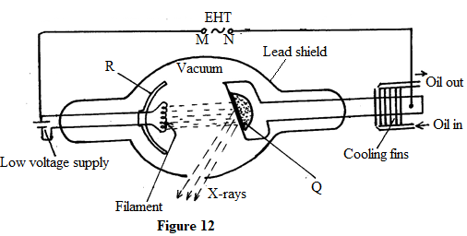
Figure 8
- State and explain how the following changes affect the nature of X-rays produced:
- increasing the potential across MN. (2 marks)
Strength of X-rays increases √; increased acceleration/velocity of electrons. √
- increasing the filament current. (2 marks)
X-ray intensity increases √; more electrons are dislodged producing more x-rays. √
- The material of Q should withstand a lot of heat. State the source of heat in the tube. (1 mark)
Some kinetic energy of accelerated electrons are converted to heat on hitting the target. √
- State the property of lead which makes it suitable as a shield. (1 mark)

-Higher density√

- Give a reason for the shape of part R. (1 mark)
- Focus produced electrons to the anode target. √

b) A 5μF and a 3μF capacitor are connected in series with a 6V battery.
- Sketch and label the circuit diagram showing the arrangement. (2 marks)
- Determine;
- The potential difference across the 5μF. (4 marks)
$$\frac{1}{C_{T}}=\frac{1}{5}+\frac{1}{3};C_{T}=1.875 F√;Q=CV;1.875x{10}^{-6}x6√=1.125x{10}^{-5}C√;V=\frac{Q}{C}=\frac{1.125x{10}^{-5}}{5x{10}^{-6}}=2.25V√$$
- The charge stored in the circuit. (1 mark)
$$1.125x{10}^{-5}C or 1.125 C√$$
- State one use of a charged gold leaf electroscope. (1 mark)
-Identify type of charge. √ any one
- Detect charge
-Determine quantity of charge.
-Identify conductors and insulators.

16.(a) State what is meant by the term mutual induction. (1 mark)
Changing magnetic flux linkage in one coil induces current /emf in another coil placed close to it. √

(b) Figure 9 shows two coils wound on a laminated soft iron core. It is connected to a 300V mains supply.
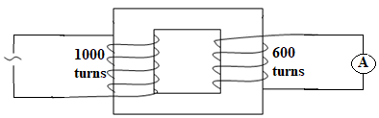
Figure 9
- Identify the type of the transformer in figure 9. (1 mark)
-Step down transformer√
- The transformer in figure 9 loses 20% of the input energy into heat per second. Determine the maximum current measured on the ammeter, if the input current is 2A.
(3 marks)
$\frac{N_{s}}{N_{p}}=\frac{V_{s}}{V_{p}} ;\frac{600}{1000}=\frac{Vs}{300} ;Vs=180V$√
$$0.8x2x300=Isx180 √;Is=2.667A√$$
(iii) Explain how energy losses in the transformer in figure 9 are minimized by having:
(I) a soft iron core. (1 mark)
Soft iron core is easily magnetized and demagnetized √; hence prevent hysteresis loss√
(II) a laminated core. (1 mark)
Laminated core increases resistance in the core√; minimizing eddy currents. √
- Figure 10 shows two identical copper coils X and Y placed close to each other. Coil X is connected to a DC power supply while coil Y is connected to a galvanometer.
Figure 10
- Explain what is observed on the galvanometer when the switch is closed. (4mks)
The galvanometer pointer first deflects then goes bac to zero/ kicks/deflects momentarily; √ When the switch is closed a current build up/grows in coil X and due to change in flux linkage an emf is induced in coil Y making an induced current flow through the galvanometer. √; When current through X is steady, no induced current flows through the galvanometer √since there is no change in flux linkage. √
- State what is observed on the galvanometer when the switch is opened. (1mk)
Pointer deflects in the opposite direction then goes back to zero or pointer kicks or deflects momentarily. √
17. (a) Apart from light moving from an optically denser medium to less dense medium, state the other condition for total internal reflection. (1 mark)
-The angle of incidence in the optically denser medium must be greater than the critical angle. √

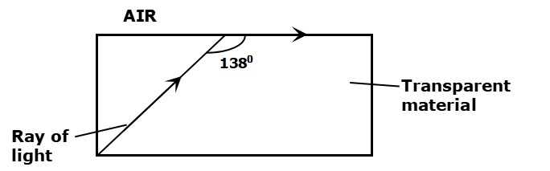
(b) Figure 11 below shows the path of light through a transparent material placed in air.
Figure 11

Determine the refractive index of the transparent material. (3marks)

$Critical angle C={138}^{0}-{90}^{0}={48}^{0}√ ;n=\frac{1}{\sin{C}}=\frac{1}{\sin{{48}^{0}}}√ ;n=1.3456$√
c) (i) Figure 12 shows an object O placed in front of an objective lens L_{o} whose focal length f_{o} is less than f_{e} the focal length of the eye piece lens L_{e}. Complete using ray construction how the arrangement would produce the final image. (3 marks)
Figure 12
- An object is placed 25cm from the objective lens of focal length 15cm.On the other side of the objective lens another converging lens of focal length 30cm is placed as the eye piece lens. The distance between the two lenses is 52.5cm. Determine;
- The position of the first image. (3 marks)
$$\frac{1}{f}=\frac{1}{u}+\frac{1}{v} ;√ ;\frac{1}{15}=\frac{1}{25}+\frac{1}{v};√;v=37.5cm √$$
- The position of the final image from the eye piece lens. (3 marks)
$$new object distace=52.5-37.5;√;\frac{1}{f}=\frac{1}{u}+\frac{1}{v};\frac{1}{30}=\frac{1}{15}+\frac{1}{v};√;v=-30cm ;30cm on same side as object.√$$
18. State two factors which determine the speed of photoelectrons emitted from a metal surface. (2 marks)
-Frequency of the radiation√
-work function of the metal surface. √
c) Figure 13 shows a graph of the square of the maximum velocity (V_{max})² of the emitted photoelectrons against the frequency (f) of the radiation causing photoelectric effect on a clean zinc plate.
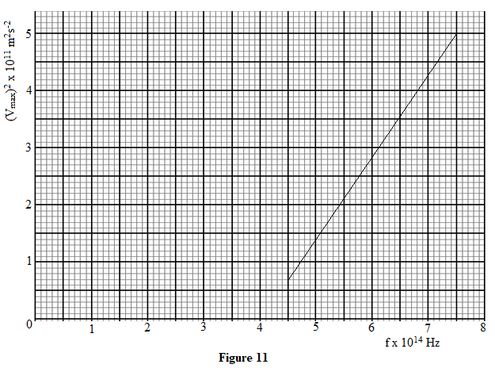
Figure 13
(i) Determine the slope of the graph. (2 marks)
$\frac{\left(5-0.7\right)x{10}^{11}}{\left(7.5-4.5\right)x{10}^{14}} √;1.433x{10}^{-3}m^{2}s^{-2}/Hz√$
The equation of the line is V² = $\frac{2h}{m}$f – $\frac{2h}{m}$f_{o} where m = 9.11 x 10⁻³¹ kg
(ii) From the graph determine the:
(I) minimum frequency of the radiation that will cause emission of electrons from the zinc surface. (1 mark)
$4.0x{10}^{14}Hz √$

(II) Planck’s constant. (2 marks)
$slope=\frac{2h}{m};1.433x{10}^{-3}=\frac{2h}{9.11x{10}^{-31}} √ ;h=6.5273x{10}^{-34}Js√$

(III) minimum amount of energy required to just emit electrons from the zinc surface. (2 marks)
$E=hf_{0};E=6.5273x{10}^{-34}x4.0x{10}^{14}√=2.611x{10}^{-19}J√$
19. Figure 14 shows a set up for observing interference of waves from two sources S₁ and S₂. The points C and D represent positions of the constructive and destructive interference respectively as observed on the screen.
Figure 14

- If the observation was made in a ripple tank, describe:
(i) How the two sets of coherent waves were produced. (2 marks)
-attach two identical dippers to the same vibrator√, switch on and then circular waves are produced√. OR use one straight vibrator with two identical slits to produce coherent waves. √
(ii) How the constructive and destructive interferences are identified. (1 mark)
Constructive- Bright√ both answers
Destructive- Dark√
- Explain how the constructive interference C and destructive interference D patterns are produced. (2 marks)
C-two waves arrive at a point in phase/ crest and crest meet or trough and trough meet√
D-two waves out of phase arrive at a point/ crest and trough meet; path difference of ½ odd wavelength. √
- Draw:
- The line joining all points where waves S₁ and S₂ have travelled equal distance. Label it A.
(1 mark)
(ii) The line joining all points where waves from S₂ have travelled one wavelength further than the waves from S_{1.} Label it B. (1 mark)
√

THIS IS THE LAST PRINTED PAGE

