Nyaraya Cluster Examination
Kenya Certificate of Secondary Education
Form Four Mock Evaluation Programme

Name……………………………………………………… Index No……………………/………

School……………………………………………….Candidate’s Sign………….….….….…...

232/3 Date……….…………………………………

PHYSICS
PAPER 3
(PRACTICAL)
July 2023
TIME: 2½ HOURS
PHYSICS PRACTICAL
TIME: 2½HOURS

INSTRUCTIONS TO THE CANDIDATE:

- Write your name, school and Index number in the spaces provided at the top of this page
- Sign and write the date of examination in the spaces provided above.
- Answer all questions in the spaces provided
- You are supposed to spend the first 15 minutes of the 2 ½ hours allowed for this paper reading the whole paper carefully before commencing your work.
- Marks are given for a clear record of the observations actually made, their suitability, accuracy and the used made of them.
- Candidates are advised to record their observations as soon as they are made.
- Non- programmable silent electronic calculator and KNEC Mathematical tables and electronic calculators may be used except where stated otherwise.

for examiners use only

Question 1 | a | e | f | g (i) | g (ii) | Total
Maximum Score | 5 | 6 | 4 | 3 | 2 | 20
Candidate’s Score

Question 2 | Part A |  |  | Part B |  |  | Total
 | a | e | f | c | d | e
Maximum Score | 3 | 6 | 3 | 1 | 3 | 4 | 20
Candidate’s Score

This paper consists of 8 printed pages. Candidates should check to ensure that all pages are
Printed as indicated and no question(s) is missing.
Question One
You are provided with the following apparatus:
  - Concave mirror
  - Mirror holder M
  - Metre rule
  - Candle
  - White screen S

Proceed as follows;

- i) Focus a distance object to the screen S and measure its image distance f₁

f₁=____________________ cm (1mark)

ii) Set the apparatus as shown figure 1

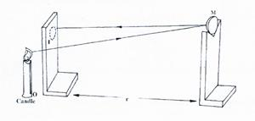Fig 1

Place the screen S and candle besides and on the same line to each other infront of the mirror the screen .Adjust the position of the mirror towards and away from the screen and candle until a sharp inverted image of the flame is focused on the screen.

Measure distance h the distance between screen S and mirror M

h =___________________cm (1 mark)

iii) Determine the values of:
I f₂ $=\frac{h}{2}$ (1mark)
………………………………………………………………………………………………………………………………………………………………………………………………

II $fo =\frac{f_{1}+f_{2}}{2}$to one decimal place (2marks)
………………………………………………………………………………………………………………………………………………………………………………………………………………………………………………………………………………………………

- Arrange the apparatus as shown in figure 2 below

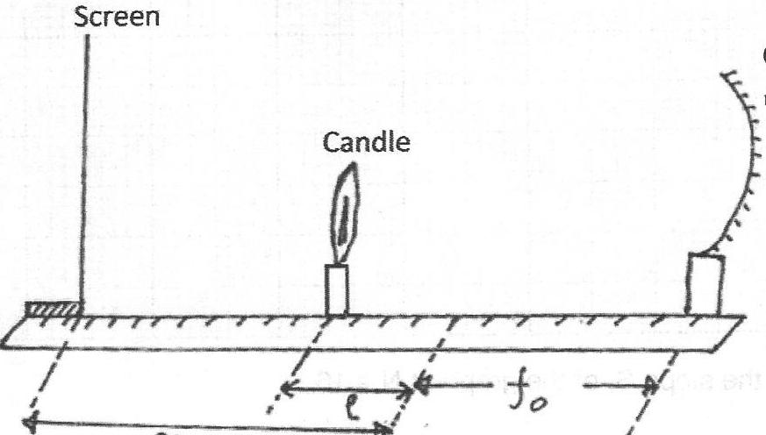
Concave mirror
X
fo
Figure 2

- Place the candle at a distance f_{o}+l from the mirror( for l=3cm )
- Starting with the screen at a distance of 100cm from the mirror, gently move it towards the mirror until a sharp inverted image is formed. Measure and record the distance x.
- Repeat step (a) to (d) for other values of l in the table 1 and record your results to complete the table 1 (6marks)

l (cm) | 3 | 5 | 7 | 10 | 13 | 15
x (cm)
(cm⁻¹)

- Plot a graph of x against (4 marks)

- From the graph ;
(i) Determine the slope S of the graph (3 marks)

………………………………………………………………………………………………………………………………………………………………………………………………………………………………………………………………………………………………
(ii) Determine f given that (2 marks)
………………………………………………………………………………………………………………………………………………………………………………………………………………………………………………………………………………………………

Question Two
Part A
You are provided with the following apparatus
- 100ml beaker
- A complete retort stand.
- Access to water.
- Stop watch.
- One 50ml burette with a tap
- Watch glass
- Plane mirror
- Some plasticine
- Piece tissue paper
Proceed as follows:
- i ) Clean the watch glass carefully and wipe dry using soft tissue paper. Place the mirror on the bench with the reflecting surface facing up. Put the watch glass on it with the centre of the watch glass resting on the centre of the mirror. Support it with plasticine.
(ii) Lower the end of burrete to a few cm above the watch glass. Run carefully and slowly from the burette water to the watch glass until volume of water on watch glass V=6.0cm³
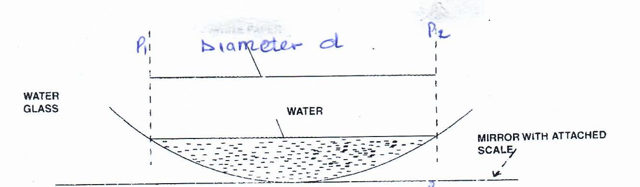
Figure 3

ii) Measure the distance d between the ends of the water on watch glass using vernier caliper
d = ____________________________________cm (1 mark)

iv) Determine R , given that V = $\frac{d^{4}}{20R}$ the radius of watch glass ( 2 marks)………………………………………………………………………………………………………………………………………………………………………………………………
- Set the apparatus as follows:
Figure 4
- Fill the burette with water to up to zero mark .Place an empty beaker below the burette
- Open the tap at once and start the stop watch simultaneously. Stop the stopwatch when the level of water in the burrete reaches 10.0cm³ mark. Record the time tin the table 2 below.
- Repeat the procedures (b) and (c) for other values of the burette readings in the table to complete table 1 below (6 marks)

Burette reading | 10.0 | 15.0 | 20.0
Volume of water remaining in the burette V cm³
Log₁₀ V
Time t (s)
ᵶ =$\frac{Log10 V}{t}$

i) Determine β, average value of ᵶ. (1mark)
………………………………………………………………………………………………………………………………………………………………………………………………………………………………………………………………………………………………
ii) Given that β =$\frac{0.639}{x}$ determine x (2marks)
……………………………………………………………………………………………………………………………………………………………………………………………………………………………………………………………………………………………

PART B
You are provided with the following apparatus
- A complete retold stand.
- Stop watch.
- A spring and with a pointer spring constant of approximately 10.0N/m.
- A 100g masses labeled M
- Metre rule

Proceed as follows
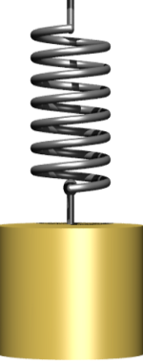
- Set the apparatus as shown below.
Pointer
Metre rule
spring
stand
M

- Hang the unloaded spring and record the pointer readings

x_{o…………………………………………….}m.
- Suspend one mass 100 g on the spring, record the new pointer reading x₁ and the extension of the spring, e.
x_{1…………………………………………………}m
e………………………………………………….m. (1mark)
- Displace the mass slightly downwards and release it to oscillate vertically. Time 20 oscillations and obtain time t and periodic time T
t ………………………………..s (1mark)

T………………………………. s (2 marks)

- Use the equation below to determine constants q and k
I) T= $2π\sqrt{\frac{e}{q}}$ (2marks)
………………………………………………………………………………………………………………………………………………………………………………………………………………………………………………………………………………………………

- T₂= $2π\sqrt{\frac{m}{K}}$ where m is mass in kg (2marks

………………………………………………………………………………………………………………………………………………………………………………………………………………………………………………………………………………………………

THIS IS THE LAST PRINTED PAGE

