Nyaraya Cluster Examination
Kenya Certificate of Secondary Education

2023 Form Four Evaluation Programme

447/1 POWER MECHANICS Paper 1
JULY/AUGUST 2023
447/1
POWER MECHANICS
Paper 1 (THEORY)
July/August
TIME -2¹/₂
NAME …………………………………………… Index Number …………………
Candidate’s signature …………………… Date ……………………………
Instructions to candidates
- Write your name and index number on the spaces provided above.
- Sign and write the date of examination in the spaces provided above.
- Candidates should have the following for this examination:
- Drawing instruments
- Scientific calculator
- Drawing paper size A4
- This paper contain two sections A and B
- Answer all questions in section A in the spaces provided.
- Answer question 11 on A4 paper and any other three questions from section B in the spaces provided.
- All dimensions are in millimetres unless otherwise stated.
For examiner’s use only
Section | question | Maximum  score | Candidates score
A | 1-10 | 40
B | 11 | 15
 |  | 15
 |  | 15
 |  | 15

SECTION A (40 marks)

Answer all questions
- (a) Define a business plan. (2mks)
…………………………………………………………………………………………………………………………………………………………………………………………………………………………………………………………………………………………………………………………………………………………………………………………………………………………………………………………………………………

(b) List down four factors that must be considered before setting up a ‘’jua kali’’ garage. (2mks)
………………………………………………………………………………………………………………………………………………………………………………………………………………………………….…………………………………………………..
…………………………………………………………………………………………………………………………………………………………………………………………………………………………………………………………………………………………………………………………………………………………………………………...
- (a) An engine with a good compression starts but does not run. Name any four engine systems that could be faulty. (2mks)
.................................................................................................................................................................................................................................................................................................................................................................................................................................................................................................................................................................................................................................................

(b) State two advantages of independent front suspension over rigid beam suspension
(2mks)
.................................................................................................................................................................................................................................................................................................................................................................................................................................................................................................................................................................................................................................................
- (a) State two reasons for having a first aid box in a vehicle. (2mks)
..................................................................................................................................................................................................................................................................................................................................................................................................................................................................................................................................................................................................................................
(b) Use sketches to differentiate between slotted hexagonal nut and a castellated nut
(2mks)

- (a) State three functional characteristics of a road wheel. (3mks)
..................................................................................................................................................................................................................................................................................................................................................................................................................................................................................................................................................................................................................................

(b) State two advantages of riveting over soldering. (1mk)
.................................................................................................................................................................................................................................................................................................................................................................................................................................................................................................................................................................................................................................................
- (a) Name four main electrical circuits in a motor vehicle. (2mks)
..................................................................................................................................................................................................................................................................................................................................................................................................................................................................................................................................................................................................................................
(b) State two types of bearing loads and for each state an area of application in motor vehicle. (2mks)
......................................................................................................................................................................................................................................................................................................................................................................................................................................................................................................
6. State the function of each of the following components: (4mks)
(i). Ball joint …………………………………………………………………………………………….............................................................................................................................
(ii). Damper …………………………………………………………………………………………………………………………………………………………………………………………
(iii). Wrist …………………………………………………………………………………………………………………………………………………………………………………………

(iv). Brake drum
……………………………………………………………………………………………..............................................................................................................................

7. (a) State the purpose of each of the following tools: (2mks)
(i). Tachometer ……………………………………………………………………………………………..............................................................................................................................
(ii).Telescopic gauge ……………………………………………………………………………………………..............................................................................................................................

(b) List four cleaning tools used during soldering. (2mks)
……………………………………………………………………………………………..............................................................................................................................
………………………………………………………………………………………..............................................................................................................................
8. (a) Explain the difference between flushing and bleeding as used in braking system
(2mks)
……………………………………………………………………………………………..............................................................................................................................……………………………………………………………………………………………..............................................................................................................................

(b) State four components operated by a multi-cylinder engine cam-shaft. (2mks)
……………………………………………………………………………………………..............................................................................................................................
……………………………………………………………………………………………..............................................................................................................................

9. (a) State four causes of vehicle swaying on turn (2mks)
……………………………………………………………………………………………..............................................................................................................................……………………………………………………………………………………………..............................................................................................................
(b) Explain the meaning of each of the following fabrication process.
(i) Forming (1mk) ………………………………………………………………………………………………………………………………………………………………………………………….

(ii) Finishing (1mk) ……………………………………………………………………………………………..............................................................................................................................
10. (a) State the energy conversion that take place in each of the vehicle components:
Horn (1mk) ……………………………………………………………………………………………..............................................................................................................................
Alternator (1mk) …………………………………………………………………………………………….............................................................................................................................

(b) Sketch the symbols for each of the following electrical devices. (2mks)
- Lamp

- Zener diode

- Capacitor

- Battery

SECTION B (60 marks)
Answer question 11 and any three questions from this section in the spaces provided. Candidates are advised not to spend more than 25 minutes on question 11.
11. A shaft support block is shown in isometric in the figure below. Draw in third angle orthographic projection:
- The plan view.
- The sectional front view in the direction A-A.
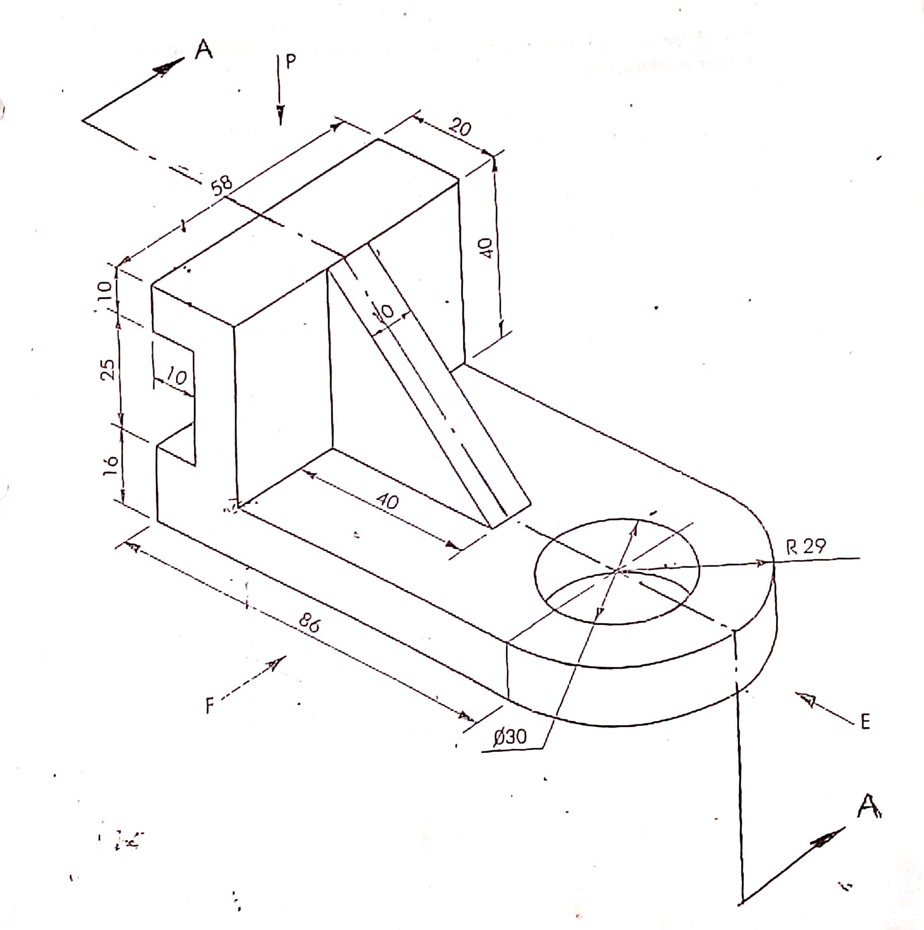

12. (a) State four functions of oil in an engine. (4mks) ………………………………………………………………………………………………………………………………………………………………………………………………………………………………………………………………………………………………………………………………………………………………………………………………
(b) Using labelled sketch, explain the operation of pressure relieve valve. (7mks)

……………………………………………………………………………………………………………………………………………………………………………………………………………………………………………………………………………………………………………………………………………………………………………………

(c) Describe the splash feed lubrication system as used in single cylinder engines.
(4mks)
…………………………………………………………………………………………………………………………………………………………………………………………………………………………………………………………………………………………………………………………………………………………………………………………………………………………………………………………………………………………………………………………………………………………………………………………………………………………………………………………………………………………………………………………………………………………………………

13. (a) State one function of each of the following charging system components.(3mks)
- Diode …………………………………………………………………………………………………………………………………………………………………………………………
- Cut-out relay …………………………………………………………………………………………………………………………………………………………………………………………
- Pole shoes. ………………………………………………………………………………………………………………………………………………………………………………………… (b) List four differences between D.C generator and an alternator. (4mks)
……………………………………………………………………………………………………………………………………………………………………………………………………………………………………………………………………………………………………………………………………………………………………………………………………………………………………………………………………………………………………………………………………………………………………………………………………………………………………………………………………………
(c) Describe the operation of an alternator. (8mks)
…………………………………………………………………………………………………………………………………………………………………………………………………………………………………………………………………………………………………………………………………………………………………………………………………………………………………………………………………………………………………………………………………………………………………………………………………………………………………………………………………………………………………………………………………………………………………………………………………………………………………………………………………………………………………………………………………………………………………………………………………………………………………………………………………………………………………………………………………………………………………………………………………………………………………………………………………………………………………………………………………………………………

14. (a) List four constant velocity universal joints. (2mks)
……………………………………………………………………………………………………………………………………………………………………………………………………………………………………………………………………………………………………………………………………………………………………………………………………………………………………………………………………………………………………………………………………………………………………………………………………………………………………………………………………………

(b) Name four gears used in the final drive. (2mks)
……………………………………………………………………………………………………………………………………………………………………………………………………………………………………………………………………………………………………………………………………………………………………………………………………………………………………………………………………………………………………………………………………………………………………………………………………………………………………………………………………………

(c) (i) Sketch and label all the parts of a final drive. (5mks)

(ii)Explain the differential principle during cornering. (6mks)
…………………………………………………………………………………………………………………………………………………………………………………………………………………………………………………………………………………………………………………………………………………………………………………………………………………………………………………………………………………………………………………………………………………………………………………………………………………………………………………………………………………………………………………………………………………………………………
15. (a) State three causes of each of the following in oxy-acetylene welding. (3mks)
- Backfire ………………………………………………………………………………………………………………………………………………………………………………………………………………………………………………………………………………………………………………………………………………………………………………………………………………………………………………………………………………………………………………………………………………………………………………
- Flash back …………………………………………………………………………………………………………………………………………………………………………………………………………………………………………………………………………………………………………………………………………………………………………………………………………………………………………………………………………………
(b) Explain four effects of oxy-acetylene flame on steel. (8mks)
……………………………………………………………………………………………………………………………………………………………………………………………………………………………………………………………………………………………………………………………………………………………………………………………………………………………………………………………………………………………………………………………………………………………………………………………………………………………………………………………………………………………………………………………………………………………………………………………………………………………………………………………………………………………………………………………………………………………………………………………………………………………………………………………………………………………………………………………………………………………………………………………………………………………………………………………………………………………………………………………………………………………………………………………………………………………………………………………………………………………………………………………………………………

(c) State four advantages of rightward method over leftward welding method. (4mks)
……………………………………………………………………………………………………………………………………………………………………………………………………………………………………………………………………………………………………………………………………………………………………………………………………………………………………………………………………………………………………………………………………………………………………………………………………………………………………………………………………………………………………………………………………………………………………………………………………………………………………………………………………………………………………………………………………………………………………

